**Nagios**

## Nagios is **an open source monitoring system for computer systems**. It was designed to run on the Linux operating system and can monitor devices running Linux, Windows and Unix operating systems (OSes). Nagios software runs periodic checks on critical parameters of application, network and server resources.

# Why we need Continuous Monitoring?

By these problems Nagios comes into picture .

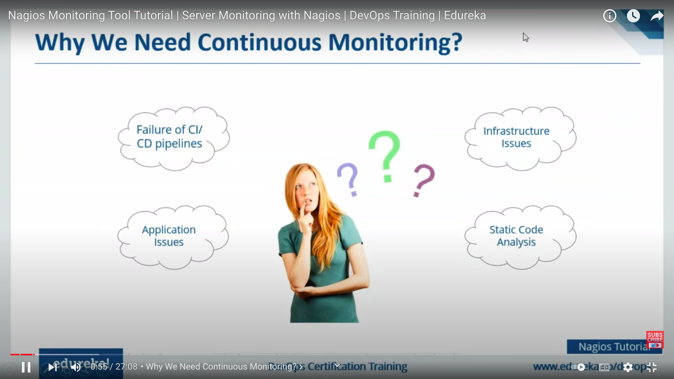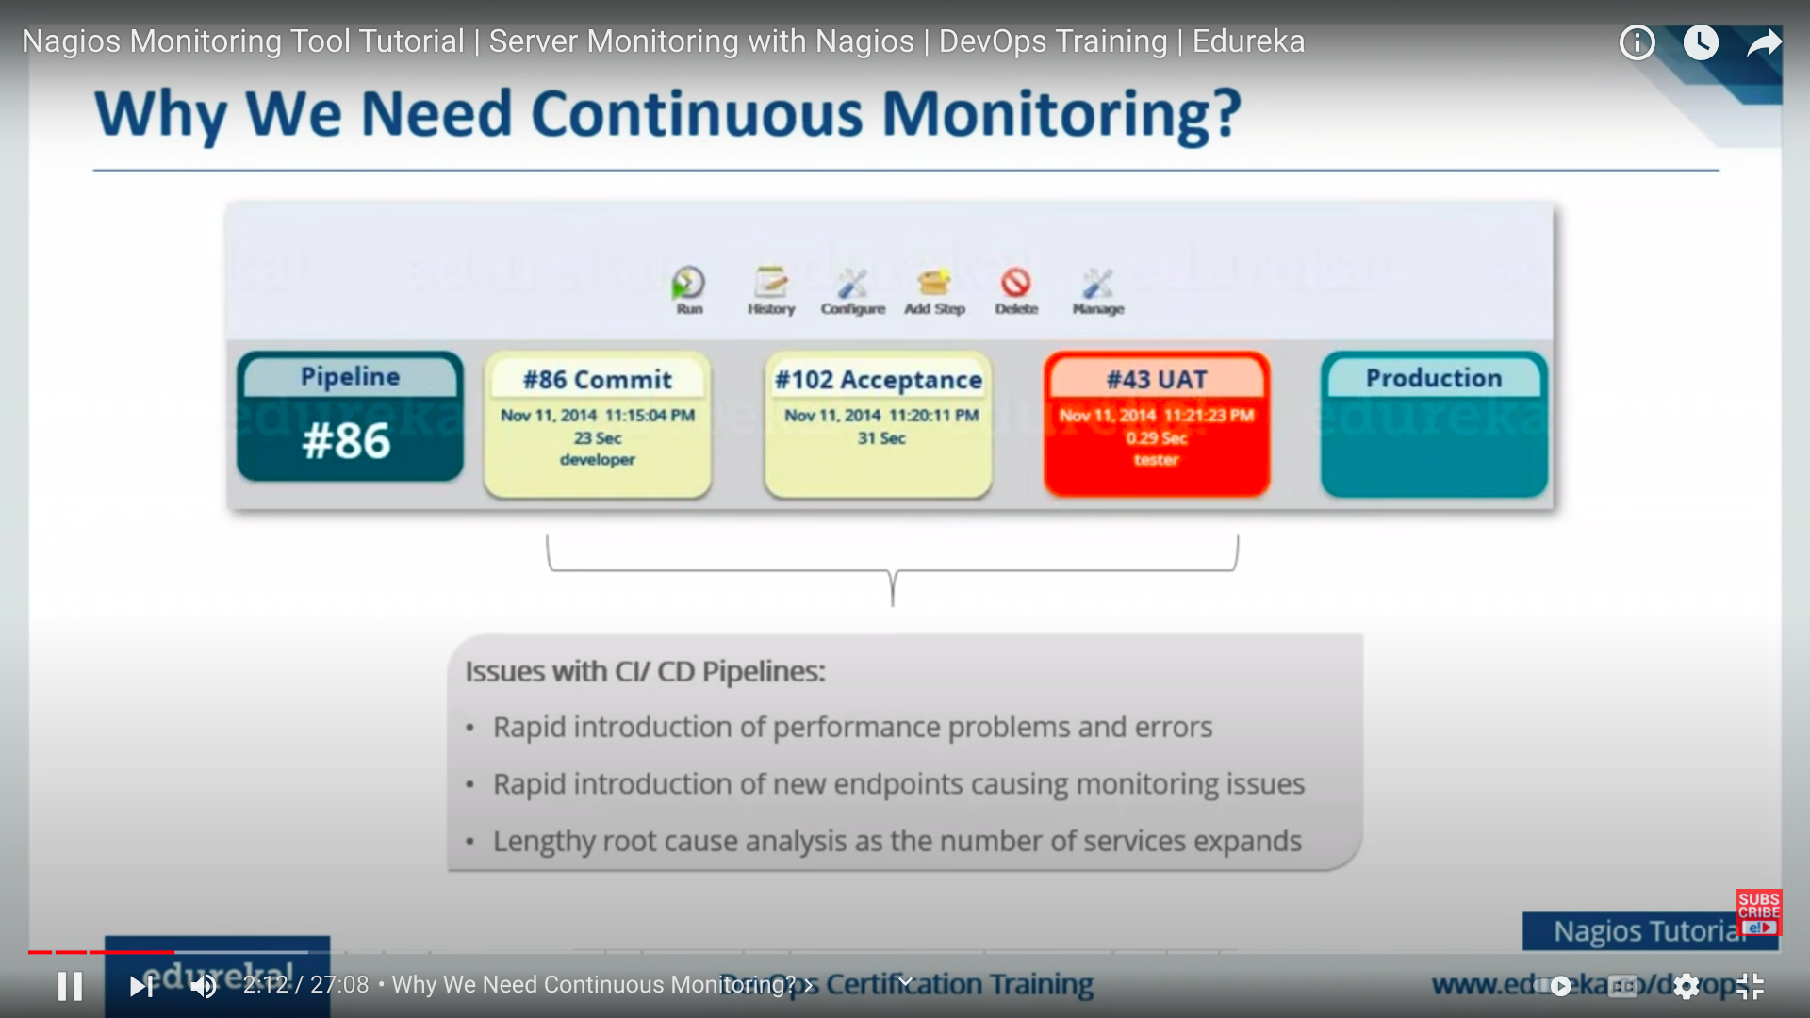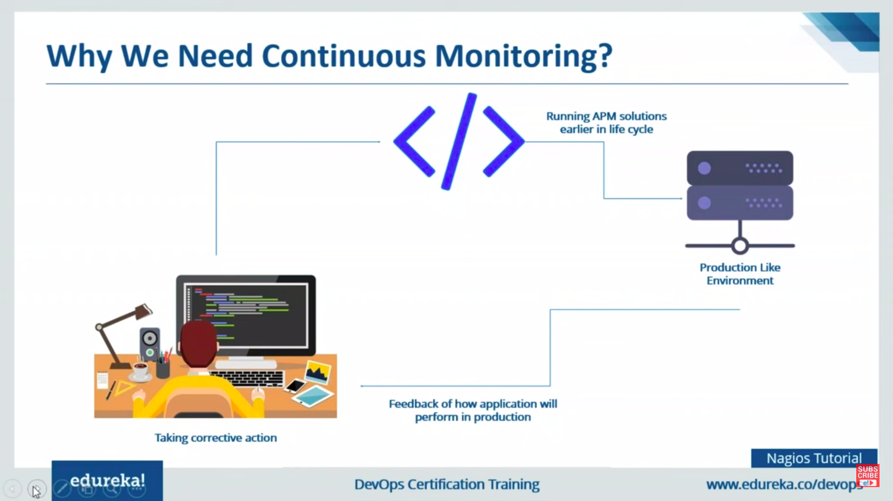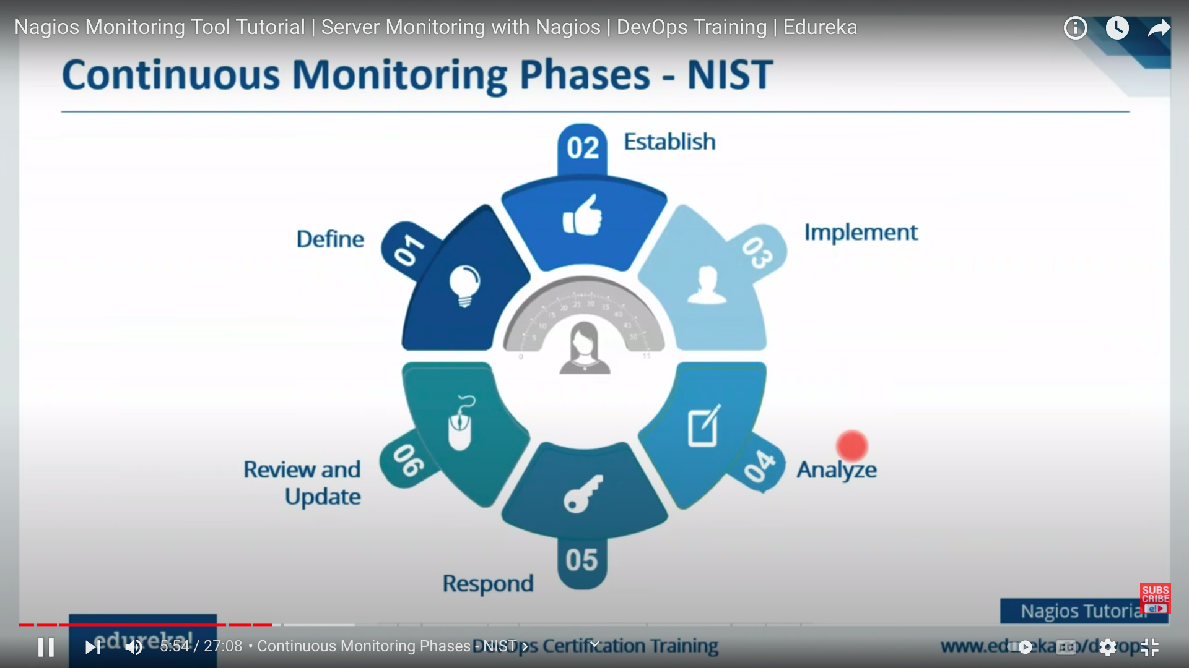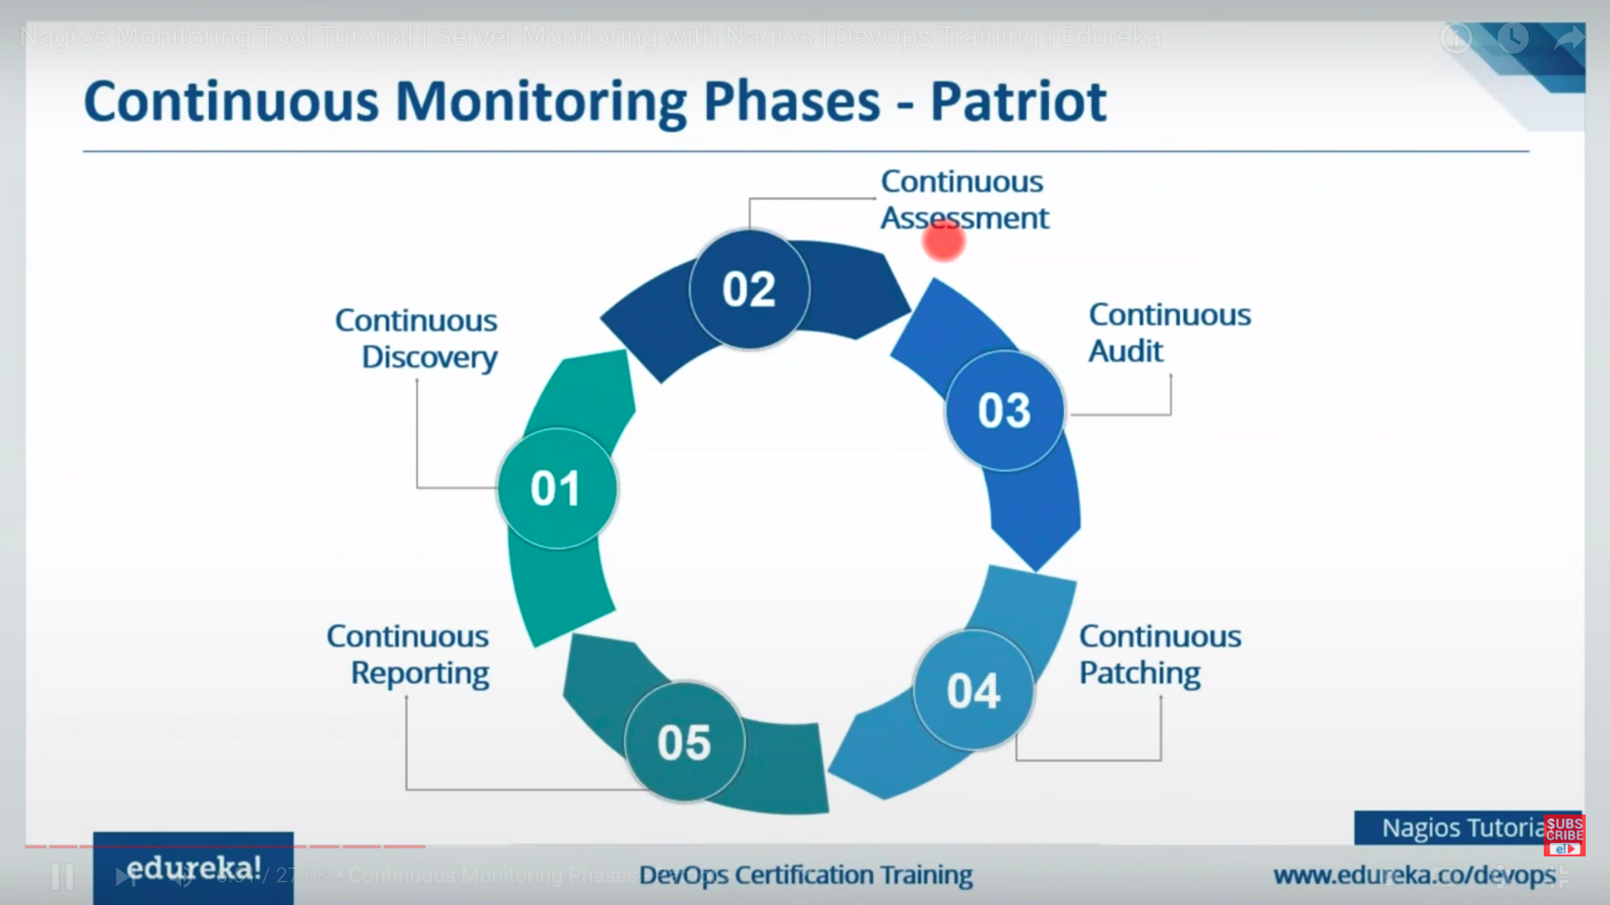Nagios is a open source monitoring system.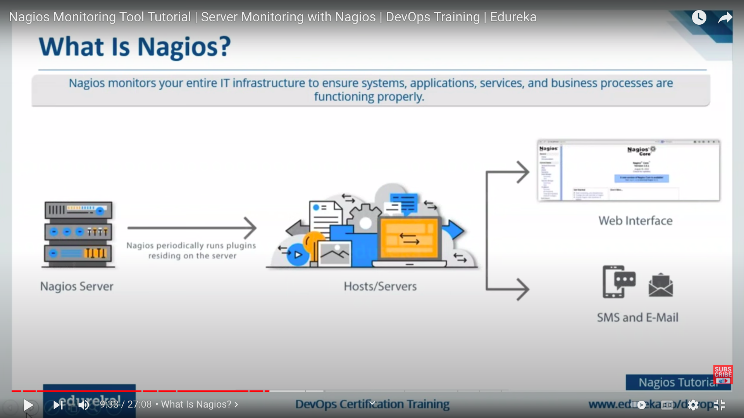Nagios Features